Setup VCPKG manager, add Boost.InterProcess.

Clone the vcpkg repository
(downloads the official vcpkg source from Microsoft)
Within /dev folder (with git already installed):
git clone https://github.com/microsoft/vcpkg.git
(this also mkdir’s
Run the vcpkg bootstrap script
This builds the vcpkg executable for Windows.
cd vcpkg
bootstrap-vcpkg.bat
After running, you will see a new file: vcpkg.exe
This is the actual package manager
Add vcpkg to your PATH (Allow to run vcpkg from any folder)
Open System Properties → Environment Variables
Add the full path to your vcpkg folder (e.g., C:\dev\vcpkg) to PATH
Restart your terminal so PATH updates
Integrate vcpkg with MSBuild and CMake
This step makes Visual Studio and CMake automatically detect installed libraries.
Within dev/vcpkg folder:
vcpkg integrate install
Install a library (example: Boost.Interprocess)
This is how you install any C++ library using vcpkg.
vcpkg install boost-interprocess (using boost for IPC)
vcpkg downloads, builds, and installs Boost
Now redirect to the target project folder (has .cpp’s and CMake files)
mkdir build (within /dev/project_folder as above), then cd build.
Use vcpkg with CMake
Tell CMake to use vcpkg’s toolchain file.
cmake -DCMAKE_TOOLCHAIN_FILE=C:/dev/vcpkg/scripts/buildsystems/vcpkg.cmake
Configuration and Installation of Boost.InterProcess for windows IPC testing.

Create CMakePresets.json file within the parent project folder to direct vcpkg build
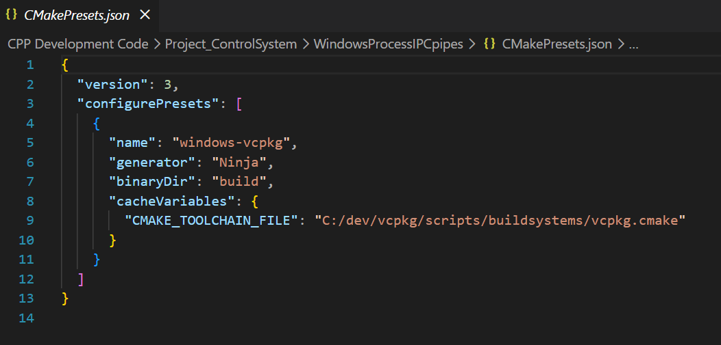

Now with the completed .cpp files ready for build –
To create the exe files run the below command in build directory ->
C:\dev\CPP Development Code\Project_ControlSystem\WindowsProcessIPCpipes\build>cmake --build . --config Debug
Then to run (in this simple framework instance the a process is required to initialise first.
Either open direct from windows or via 2 separate terminal instances.
Terminal 1
C:\dev\CPP Development Code\Project_ControlSystem\WindowsProcessIPCpipes\build>cd debug
C:\dev\CPP Development Code\Project_ControlSystem\WindowsProcessIPCpipes\build\Debug>process_a.exe
Terminal 2
C:\dev\CPP Development Code\Project_ControlSystem\WindowsProcessIPCpipes\build>cd debug
C:\dev\CPP Development Code\Project_ControlSystem\WindowsProcessIPCpipes\build\Debug>process_b.exe

When developed into meaningful process/programs (run detached) – (program keeps running after terminal closes)
Start-Process .\process_a.exe
Start-Process .\process_b.exe

